English
In writing we will be using Cosmic by Frank Cottrell-Boyce to inspire our own sci-fi stories. We will be focusing on our use of different parenthesis and conjunctions to add details and capture our readers imagination. We will also use our new science knowledge to create a biography for an astronaut. Our guided reading is also based on Cosmic for the term. We are going to work hard on our inference skills and answering 3 mark questions.

Science
The class will be learning about space. We will explore our solar system and the Big Bang Theory. We will also look in detail at the moon and the people that have travelled there. In following half term, we will be delving into meteorology and learning about why we experience different weathers.
Music
Throughout the year we will have a member of the Suffolk County Music Service coming to teach us all the ukelele. This term we will be focusing on learning notes to create rhythms. We will practice keeping a steady beat and developing our musical vocabulary. The children will also work together to develop their ensemble and performance skills.

French
This term we will be deepening our vocabulary knowledge using the story of Goldilocks and the Three Bears followed by looking at common objects and phrases around the classroom.
Maths
This term we will be focusing on developing our number knowledge by looking at multiplication and division. As part of this children will develop their confidence with word problems. We will also look at fractions which we will then use to explore decimals (Year 4) and percentages (Year 5).

ical Development which part of the body is associated 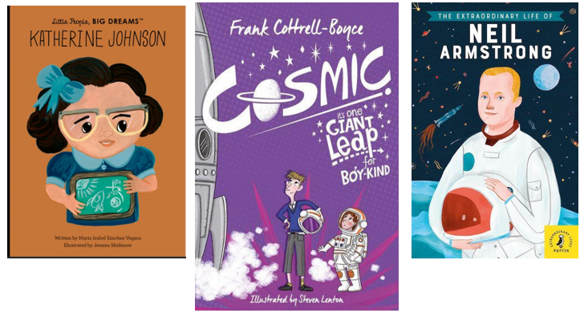with ea ch of t he 5 senses. Identifying and classifying a variety of
common animals. Describing and comparing the appearance and diet of common animals.

Focus texts:

Art/DT
The class will focus on printing in the first half term. Using the works of Rembrandt and Hokusai as inspiration, we will explore screen printing and mono-printing using Perspex. In DT we will be cooking. Over the course of the half term, we will look at the health benefits and history of different ingredients and make pita breads and honey cakes.

RE
In the first half we will be learning about Hinduism with the question:
What spiritual pathways to Moksha are written about in Hindu scriptures?
In the second half we will be learning about Judaism with the question:
What is holiness for Jewish people: a place, a time, an object or something else?

Computing
This term, we will be developing programming skills using algorithms and micro bits. In the second half of the term, we will be looking at databases.

P.E
Our sports this term will begin with gymnastics and netball followed by fitness and netball. We will focus on our teamwork, control, agility and co-ordination and stamina.
PSHE
Our focus at the beginning of term is internet safety. As part of this we will look at what is meant by ‘spam’ emails, how to stay safe online and understanding that not everything online can be trusted. After half term we will focus on mental health and how it can be affected.
History/Geography
We will start with history, looking at the transatlantic slave trade. We will talk about the effects it had, how it developed and how it was abolished. In the second half term, we will focus on the geography of our local area and how this compares to other places within the UK.

