Literacy

Reception – applying the sounds we have learned to far to read and then write CVC words. Listen to and respond to stories, putting events in the right order. Orally composing information sentences. We will continue with our mark making skills as our writing develops. We will also be strengthening our bodies with fine motor and gross motor activities that help us get ready for writing.
Year 1 – writing letters, captions, diary entries and lists. Our unit on the Naughty Bus will finish with writing our own adventure story. We will continue to work on our understanding of stories, ordering events, giving reasons for what characters do and considering how characters might be feeling in stories.

PSHE
We are going to be celebrating differences. We will learn about: things we are good at, what it means to feel proud, how I am special and unique, my family and my home, other people’s families and homes and making new friends.

Phonics
Reception - Continue with Phase 2 before moving onto Phase 3.
Year 1 - Begin Phase 5: alternative spellings of phonemes already learnt.

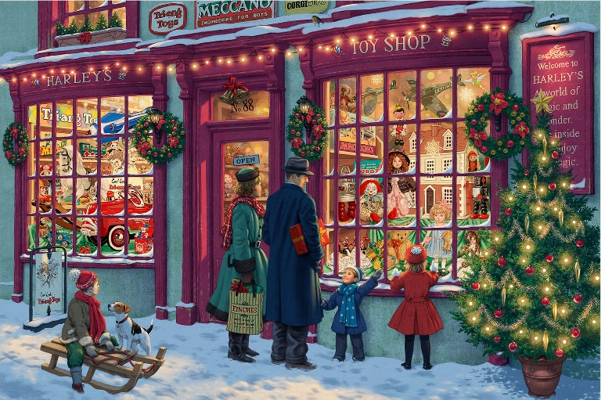
Geography
In this unit children will start by looking at aerial photographs as their first step to understanding maps. They will be introduced to different map symbols and learn about keys on maps. They will also find out about North, South, East and West.and look at routes on maps

Science
In science this half term, Year 1 will learn to distinguish everyday objects from the material they are made from. They will recognise everyday materials such as wood, plastic, glass, metal and rock. They will become familiar with key vocabulary used to describe everyday materials, such as soft, hard, flexible, strong, opaque and transparent. They will compare and group together materials based on their properties.
Reception will start to investigate materials through our topic of toys and looking at what the toys are made from. We will begin to think about where the materials come from and why they have been chosen.
Maths
We will all begin this half-term by looking at shapes. We will be identifying, naming, sorting and describing a range of 2D and 3D shapes.
Reception will then move on to numbers to 5. They will learn to count, order, represent and make the total of these numbers by learning about number bonds.
Year 1 will be revisiting addition and subtraction including part-whole models, fact families and problem solving.

Focus texts:
Naughty Bus – Literacy Tree

Toys in Space - Mini Grey

Oi! Get Off Our Train - John Burningham

Computing - Creating media – Digital painting
Children will develop their understanding of a range of tools used for digital painting. They will then use these tools to create their own digital paintings, while gaining inspiration from a range of artists’ work. We finish the unit with children considering their preferences when painting with and without the use of digital devices.

RE
In RE we will be learning about Christianity and Judaism. We will be investigating and answering the questions:
Reception: Why do Christians perform Nativity plays at Christmas?
Year 1: Why is learning to do good deeds so important to Jewish people?

DT
Using our English texts as inspiration, we will design, make and evaluate a toy of our own. We will also make puppets and wands.

Music – My Stories
In this unit we will listen to music from different parts of the world. We will also listen to and learn some nursery rhymes. Part of our music this half term will also be through learning songs for our Nativity play.

PE
Our PE this half-term is a dance unit. We will be learning to negotiate space safely and move in a range of ways. We will explore moving to music and movements to represent a character.

