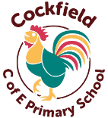
Cockfield Primary School Curriculum Overview Spring

Reception and Year 1: Lime Class – Mrs Swain

English

Spring 1 – This term we will be focusing on the book The Queens Hat. We will be exploring features of an adventure narrative and building key skills to independently write. We will also look at non – chronological reports, identifying key features and creating our own sentences.

Spring 2 – Next term we will be looking at poetry, exploring the text, By Myself. We will also continue our learning on non – fiction texts by looking at the information text, Seasons.

RE

Spring 1 - We will be learning about Christianity with the question:
What did Jesus teach about God in his Parables?
Spring 2 - We will be learning about Christianity with the question:
Why do Christians pray to God and Worship him?
PSHE

Spring 1 - Our focus this half term will be Online Safety. The children will learn about the potential dangers in the online world and the basic steps to take to have a positive experience.
Spring 2 – After our half term break, we will be looking at Health and Wellbeing – Think Positive. We will be exploring the importance of recognising, talking and accepting our feelings, both negative and positive, and learning ways of managing emotions.

Art/DT

Spring 1 – The children will be making animal sock puppets this half term. They will look closely at puppets and their use, and then design and make their own.
Spring 2 – We will be introducing the children to art of designing buildings. We will be looking specifically at famous London Landmarks, e.g. St Paul’s Cathedral.
Maths

Reception – This term we will be continuing our learning of numbers, with the expectation that the children will have a secure understanding of numbers up to 10 by Summer Term. They will also begin to explore 4 sided shapes and measurement.
Year 1 - This term we will be continuing our learning of number, looking at Place Value within 20 and 50 and Addition and Subtraction within 20. We will also be learning about Geometry (Shape) and Measurement (Length and Height, Mass and Volume).

Focus texts

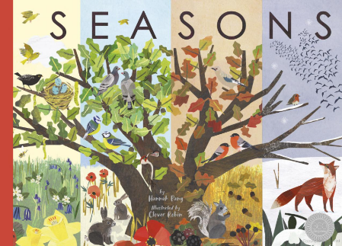
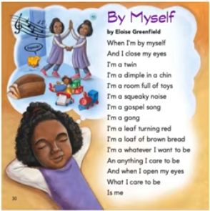

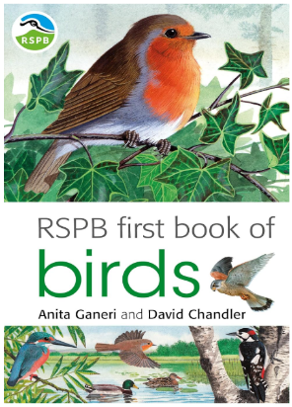
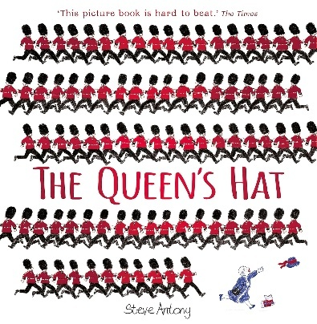
History/Geography

Spring 1 – We will start our term by learning about Kings, Queens and Leaders. We will explore how the monarchy has changed over time, focusing on significant Kings, Queens and Leaders.
Spring 2 - Next half term we will be learning about the UK. We will look at the four countries that make up the United Kingdom and their characteristics.

Science

Spring 1 – The children will be learning about Animals and their Needs. We will be learning animal names, discussing features of animals, learning about animal offspring (babies) and their names e.g. sheep and lamb.
Spring 2 – After the half term break, the children will be learning all about The Seasons. The children will learn to recognise seasonal and daily changes in the weather.

Music

Spring 1 – Rhythm in the ways we walk

Spring 2 – In the groove (glockenspiels)
P.E

Spring 1
Mon - Gymnastics – Traditional Tales
Tue - Basketball

Spring 2
Mon - Dance – The Seasons
Tue - Volleyball
Computing

Spring 1 – Programming A – Moving a robot

Spring 2 – Data and information – Grouping Data

