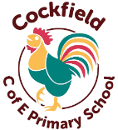
Cockfield Primary School Curriculum Overview Spring

Year 2 and Year 3: Oak Class – Miss Jones

English

Spring 1
In English, we will be using the book The Dragon Machine by Helen Ward. Children will start with exciting activities like spotting a dragon tail and going on a dragon hunt around school. They will then create a guide using descriptive and positional language, write letters to explore the main character’s thoughts and feelings, and finally plan and write their own imaginative ‘dragon machine’ story.
Spring 2
In English, we will be exploring the poem The Owl and the Pussy-cat by Edward Lear. Children will think about the themes of the poem, write from the characters’ points of view, take part in creative activities like interviews and lists, and finally use their imagination to create their own version of the poem.

Science

Spring 1
This term, children will learn about Electricity by exploring how it is used in everyday life and how to stay safe around it. They will investigate electrical appliances, create simple circuits using batteries, wires, bulbs, and switches, and discover which materials conduct electricity and which do not. Through hands-on activities, they will develop an understanding of how electricity works and why safety is so important.
Spring 2
In our Plants topic, children will explore what plants need to grow and stay healthy, observe how seeds and bulbs develop, and learn about the different parts of a plant and their functions. They will investigate how water moves through plants and the role of flowers in pollination and seed formation. Practical experiments will help them understand the life cycle of plants and why they are essential for life on Earth.

Focus texts

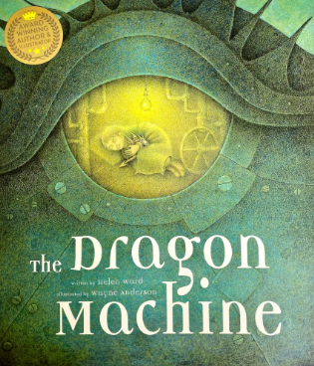
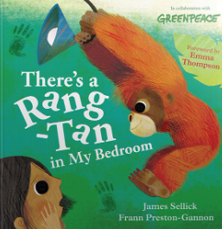

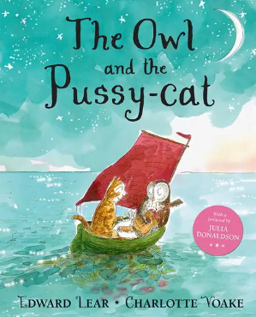

Maths

Year 2
In Maths, Year 2 will be learning about Shape, Money, and Multiplication and Division. Children will explore 2D and 3D shapes and their properties, understand the value of coins and notes while solving money problems, and develop strategies for multiplying and dividing numbers.
Year 3
In Maths, Year 3 will focus on Multiplication and Division, and Length and Perimeter. Children will develop strategies for multiplying and dividing numbers and learn how to measure length accurately and calculate the perimeter of different shapes.

Computing

Spring 1 – Programming A – Robot algorithms

Spring 2 – Data and information - Pictograms
History/Geography

Spring 1
This half term, in History, children will be learning about the Tudors. They will explore who the Tudors were, key monarchs such as Henry VIII and Elizabeth I, and what life was like during Tudor times. Through engaging activities, they will discover how the Tudors changed England and why this period is still important today.
Spring 2
Next half term, in Geography, children will learn about Rivers and their importance in the natural world. They will explore how rivers are formed, the different parts of a river, and the role rivers play in shaping landscapes and supporting life. Children will also look at major rivers in the UK and around the world and consider how humans use and care for these vital waterways.

RE

Spring 1
Judaism - Why do Jewish families talk about repentance at New Years?
Spring 2
Christianity – What are the best symbols of Jesus’ death and resurrection at death.

P.E

Spring 1 – Keeping FIt
Spring 2 - Gymnastics (floor)

Music

Spring 1 - I wanna play in a band
Spring 2 - Zootime

Art/DT

Spring 1
This half term in Art, children will explore portraits and self-portraits. They will study how artists represent people, experiment with different techniques and materials, and learn how to capture facial features and expressions. Children will then create their own portraits and self-portraits, developing observation skills and creativity.
Spring 2
Next half term in DT, children will design and make their own pencil cases. They will learn basic sewing skills, explore different stitches, and think carefully about materials and design choices. By planning, creating, and evaluating their finished product, children will develop practical skills and creativity while producing something useful.

French

Spring 1 - Dans la jungle
Spring 2 – Les petite betes

PSHE

Spring 1
This half term in PSHE, our topic is Dreams and Goals. We will be exploring aspirations and how to set and achieve goals, as well as understanding the feelings and emotions that come with working towards them.
Spring 2
Our PSHE topic next half term will be Healthy Me. Children will learn about the importance of keeping themselves safe and healthy, including making good choices for their bodies and minds.

